**Regeneron Science Talent Search: Engaging the Next Generation of STEM Leaders**

**About the Entrants, Scholars and Finalists**

This year, 2,162 high school seniors entered the Regeneron Science Talent Search, hailing from 712 high schools across 46 states, Washington, D.C., Puerto Rico, and 10 countries.

On January 10, the field of entrants was narrowed to 300 scholars from 196 American and international high schools in 36 states including China. Each of the 300 scholars and their schools were awarded $2,000.

On January 24, 40 finalists were announced from the pool of scholars, representing 36 high schools across 19 states. Finalists participated in an in-person competition March 7-13, during which they competed for more than $1.8 million in awards provided by Regeneron, including the top $250,000 prize.

**Location of Scholars’ Schools**

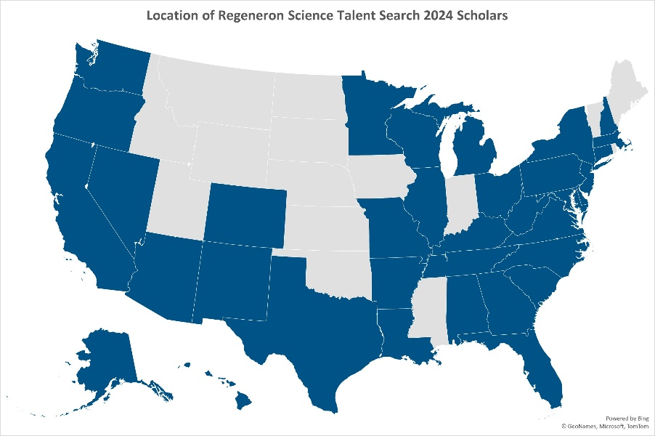

**About the Finalists’ Projects**

Finalists’ projects represent a wide range of topics. The top five categories this year are:

* Medicine and Health
* Cellular and Molecular Biology
* Neuroscience
* Computer Science
* Mathematics

This year, we’ve seen an increase in medicine and health, neuroscience, computer science, and sustained interest in cellular and molecular biology as more students continue to grow their interest in public health and artificial intelligence.

**Regeneron STS 2024 Entrants’ Research Environment**

Similar to last year’s competition, many students across entrants, scholars and finalists completed their

research at home; and we are seeing more students complete in-person work, from colleges and

universities to standalone research institutions.

**About the Competition**

All eligible students completed an original research project and an extensive application process. Projects span a diverse range of STEM-related topics, and entrants were judged based on their exceptional research skills, commitment to academics, innovative thinking, and potential to become world-changing scientists and leaders.

The 2024 competition was in-person, and finalists received an all-expense-paid trip to Washington, D.C. from March 7-13. During the competition week, the finalists underwent a rigorous judging process, including interviews with panels of judges about their research projects, and with questions covering all areas of STEM. Finalists also displayed their research for the public on March 10. Winners were announced during an awards ceremony hosted by Soledad O’Brien on March 12.

**History of the Regeneron Science Talent Search**

The [Regeneron Science Talent Search](https://student.societyforscience.org/regeneron-sts), founded and produced by [Society for Science](https://www.societyforscience.org/), is the nation’s oldest and most prestigious science and math competition for high school seniors. It recognizes and empowers promising young scientists in the U.S. who are bringing a fresh perspective to solving significant global challenges through rigorous research and novel discoveries.

Founded in 1942, the Science Talent Search program alumni include recipients of the world's most coveted science and math honors, including 13 Nobel Prizes, 13 National Medals of Science, six Breakthrough Prizes, 22 MacArthur Foundation Fellowships and two Fields Medals.

In 2017, [Regeneron](https://www.regeneron.com/) became the third sponsor of the Science Talent Search, following previous sponsorships by Westinghouse and Intel, to help reward and celebrate the best and brightest young minds and encourage them to pursue careers in STEM as a way to positively impact the world. Through its 10-year, $100 million commitment, Regeneron distributes nearly $3.1 million in awards annually, with a top award of $250,000, and $2,000 each to the top 300 scholars and their schools, to inspire more young people to engage in science.

###